1. Emission per capita income of Canada =17.72

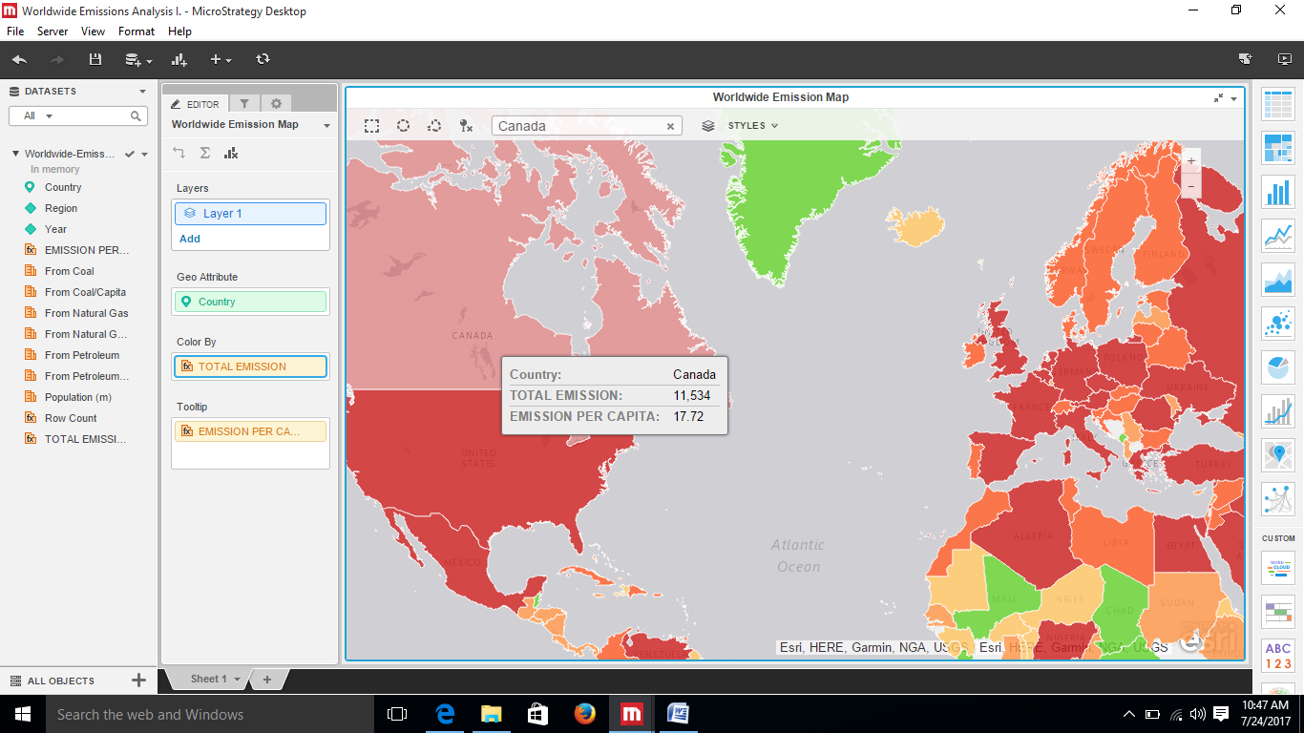

2. Overall trend in worldwide emission increasing except decrease in 2009

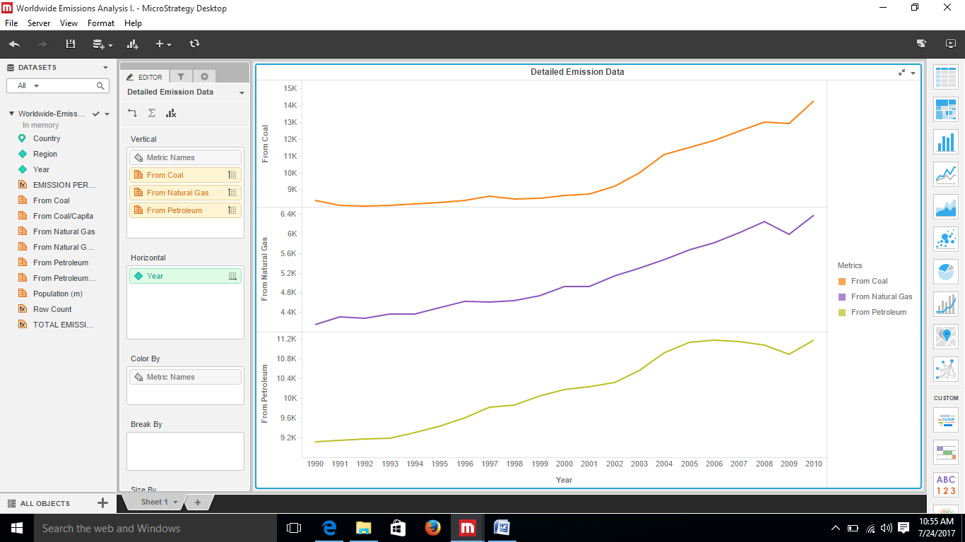

3. Emission analysis of Canada is

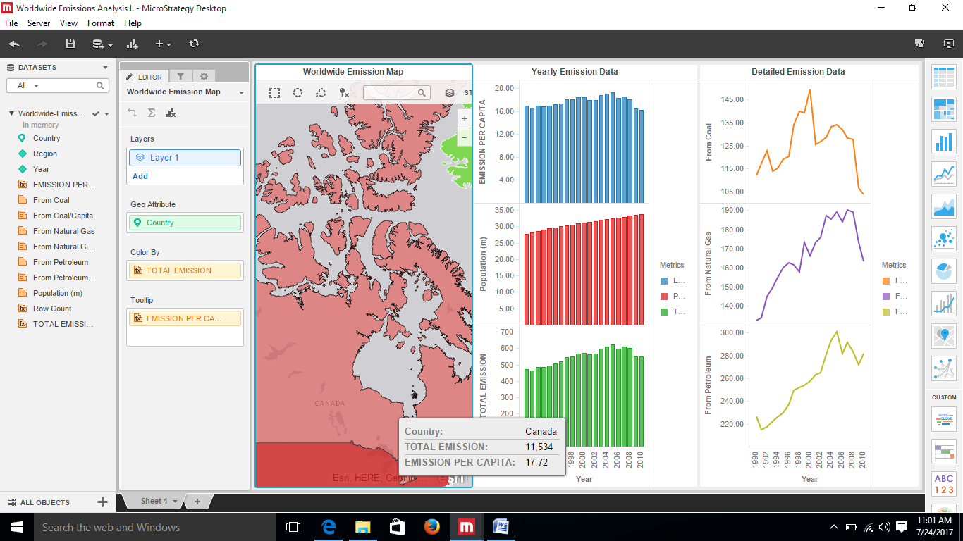

USA

